#http://www.face.ufg.br/siteface_files/midias/original-nt-002.pdf

pib<-read.delim2("D:/Google Drive/2 - Ufpb/P5/Econometria/Cap4/Dados/pib.txt")  
pib

## Data PIB  
## 1 1990.01 0.2  
## 2 1990.02 0.4  
## 3 1990.03 0.8  
## 4 1990.04 0.7  
## 5 1990.05 0.8  
## 6 1990.06 0.8  
## 7 1990.07 0.9  
## 8 1990.08 1  
## 9 1990.09 1.1  
## 10 1990.10 1.4  
## 11 1990.11 1.7  
## 12 1990.12 1.8  
## 13 1991.01 2.1  
## 14 1991.02 2.4  
## 15 1991.03 2.5  
## 16 1991.04 3.1  
## 17 1991.05 3.6  
## 18 1991.06 4.1  
## 19 1991.07 4.6  
## 20 1991.08 5.3  
## 21 1991.09 5.6  
## 22 1991.10 7.5  
## 23 1991.11 9.2  
## 24 1991.12 10.5  
## 25 1992.01 13.1  
## 26 1992.02 16.3  
## 27 1992.03 19.6  
## 28 1992.04 23.6  
## 29 1992.05 30.1  
## 30 1992.06 37.5  
## 31 1992.07 46.1  
## 32 1992.08 56.7  
## 33 1992.09 70.8  
## 34 1992.10 89  
## 35 1992.11 110.4  
## 36 1992.12 127.7  
## 37 1993.01 164  
## 38 1993.02 206.9  
## 39 1993.03 294.6  
## 40 1993.04 368.1  
## 41 1993.05 481.6  
## 42 1993.06 613.5  
## 43 1993.07 841.4  
## 44 1993.08 1149.5  
## 45 1993.09 1578.4  
## 46 1993.10 2071.3  
## 47 1993.11 2792.8  
## 48 1993.12 3534.9  
## 49 1994.01 4562.8  
## 50 1994.02 5793  
## 51 1994.03 8520.4  
## 52 1994.04 12828.8  
## 53 1994.05 20504.2  
## 54 1994.06 33126.6  
## 55 1994.07 40788  
## 56 1994.08 43873.4  
## 57 1994.09 43836.2  
## 58 1994.10 45234.9  
## 59 1994.11 45926.2  
## 60 1994.12 44210.2  
## 61 1995.01 47028.6  
## 62 1995.02 49954.5  
## 63 1995.03 60024.3  
## 64 1995.04 57789.5  
## 65 1995.05 56350.5  
## 66 1995.06 56726.2  
## 67 1995.07 58788.1  
## 68 1995.08 60950.3  
## 69 1995.09 60610.8  
## 70 1995.10 63428.1  
## 71 1995.11 67762.9  
## 72 1995.12 66577.7  
## 73 1996.01 64133.3  
## 74 1996.02 62202.2  
## 75 1996.03 62987.8  
## 76 1996.04 64019.1  
## 77 1996.05 69488.7  
## 78 1996.06 71103  
## 79 1996.07 74969.9  
## 80 1996.08 74798.8  
## 81 1996.09 71744.6  
## 82 1996.10 77200.1  
## 83 1996.11 80449.1  
## 84 1996.12 81667.1  
## 85 1997.01 77582.6  
## 86 1997.02 71072.8  
## 87 1997.03 70461.6  
## 88 1997.04 73576.4  
## 89 1997.05 78110.8  
## 90 1997.06 81202.4  
## 91 1997.07 82058.7  
## 92 1997.08 82132.5  
## 93 1997.09 81987.3  
## 94 1997.10 87297.2  
## 95 1997.11 85390.1  
## 96 1997.12 81216.8  
## 97 1998.01 79363.9  
## 98 1998.02 75828.1  
## 99 1998.03 80508.7  
## 100 1998.04 81166.1  
## 101 1998.05 85207.5  
## 102 1998.06 85562.4  
## 103 1998.07 86938.5  
## 104 1998.08 86371.3  
## 105 1998.09 84733.5  
## 106 1998.10 87302.8  
## 107 1998.11 86316.5  
## 108 1998.12 83051.8  
## 109 1999.01 80936.3  
## 110 1999.02 80929.1  
## 111 1999.03 88802.6  
## 112 1999.04 87739  
## 113 1999.05 89223  
## 114 1999.06 91746.9  
## 115 1999.07 91230.4  
## 116 1999.08 92283.4  
## 117 1999.09 90611.8  
## 118 1999.10 95872.4  
## 119 1999.11 99563.1  
## 120 1999.12 98772.5  
## 121 2000.01 92576.6  
## 122 2000.02 91770.4  
## 123 2000.03 92579.9  
## 124 2000.04 91376.2  
## 125 2000.05 98727  
## 126 2000.06 102685.4  
## 127 2000.07 103410.4  
## 128 2000.08 105177.8  
## 129 2000.09 100307.6  
## 130 2000.10 106951.1  
## 131 2000.11 107678  
## 132 2000.12 105851.6  
## 133 2001.01 102530.7  
## 134 2001.02 101635.3  
## 135 2001.03 108303.8  
## 136 2001.04 107572  
## 137 2001.05 111202.2  
## 138 2001.06 104949.4  
## 139 2001.07 110758.9  
## 140 2001.08 113064.7  
## 141 2001.09 108700.8  
## 142 2001.10 116139  
## 143 2001.11 117882  
## 144 2001.12 113016.7  
## 145 2002.01 112374.8  
## 146 2002.02 111477.1  
## 147 2002.03 118444.7  
## 148 2002.04 120385.9  
## 149 2002.05 123552.5  
## 150 2002.06 123424.4  
## 151 2002.07 126856.6  
## 152 2002.08 127800.1  
## 153 2002.09 125137.8  
## 154 2002.10 133125.4  
## 155 2002.11 135966.6  
## 156 2002.12 130241.2  
## 157 2003.01 127177.5  
## 158 2003.02 131373.6  
## 159 2003.03 138690.5  
## 160 2003.04 141388.1  
## 161 2003.05 139605.8  
## 162 2003.06 137993.4  
## 163 2003.07 145970.6  
## 164 2003.08 144819.4  
## 165 2003.09 148559.8  
## 166 2003.10 154925.9  
## 167 2003.11 153644.4  
## 168 2003.12 153801.4  
## 169 2004.01 144558.6  
## 170 2004.02 142861.3  
## 171 2004.03 157363.5  
## 172 2004.04 156953.9  
## 173 2004.05 159498.9  
## 174 2004.06 165342.2  
## 175 2004.07 171370.9  
## 176 2004.08 169178.9  
## 177 2004.09 164702.5  
## 178 2004.10 170536.5  
## 179 2004.11 176921.5  
## 180 2004.12 178462.4  
## 181 2005.01 163540.1  
## 182 2005.02 160701.6  
## 183 2005.03 175468.7  
## 184 2005.04 177179  
## 185 2005.05 177496.7  
## 186 2005.06 180881.8  
## 187 2005.07 184073.7  
## 188 2005.08 187246.6  
## 189 2005.09 181538.9  
## 190 2005.10 189183  
## 191 2005.11 194794.5  
## 192 2005.12 198480  
## 193 2006.01 185564.8  
## 194 2006.02 178482.2  
## 195 2006.03 190223.3  
## 196 2006.04 185030.6  
## 197 2006.05 197874.3  
## 198 2006.06 199071.9  
## 199 2006.07 206974.4  
## 200 2006.08 209818  
## 201 2006.09 201055.4  
## 202 2006.10 214271.7  
## 203 2006.11 219724.2  
## 204 2006.12 221359.3  
## 205 2007.01 211130.7  
## 206 2007.02 202704.1  
## 207 2007.03 217588.9  
## 208 2007.04 215128.8  
## 209 2007.05 226537.9  
## 210 2007.06 228988.6  
## 211 2007.07 233824.1  
## 212 2007.08 235019.1  
## 213 2007.09 223002.7  
## 214 2007.10 241939.4  
## 215 2007.11 241938.4  
## 216 2007.12 242460.2  
## 217 2008.01 237247.7  
## 218 2008.02 232680.4  
## 219 2008.03 242124.4  
## 220 2008.04 248793.8  
## 221 2008.05 254936.9  
## 222 2008.06 265791.2  
## 223 2008.07 278095.6  
## 224 2008.08 269235.6  
## 225 2008.09 265271.2  
## 226 2008.10 280522.5  
## 227 2008.11 270698.8  
## 228 2008.12 264404.8  
## 229 2009.01 249934.4  
## 230 2009.02 244024.5  
## 231 2009.03 262181.7  
## 232 2009.04 259563.5  
## 233 2009.05 268324  
## 234 2009.06 275701.2  
## 235 2009.07 285444.2  
## 236 2009.08 284240.4  
## 237 2009.09 283157.9  
## 238 2009.10 301895.9  
## 239 2009.11 305048.8  
## 240 2009.12 313522.8  
## 241 2010.01 288972.8  
## 242 2010.02 285723.2  
## 243 2010.03 311651.6  
## 244 2010.04 307083.5  
## 245 2010.05 315988.4  
## 246 2010.06 321023.2  
## 247 2010.07 332454.2  
## 248 2010.08 334225.6  
## 249 2010.09 331255.9  
## 250 2010.10 344963.8  
## 251 2010.11 356707.5  
## 252 2010.12 355797.4  
## 253 2011.01 333255.6  
## 254 2011.02 334982  
## 255 2011.03 347879.6  
## 256 2011.04 349049.3  
## 257 2011.05 366256.2  
## 258 2011.06 370951.2  
## 259 2011.07 373143.3  
## 260 2011.08 376769.3  
## 261 2011.09 361724.6  
## 262 2011.10 378491  
## 263 2011.11 389560.8  
## 264 2011.12 391595.1  
## 265 2012.01 367215.4  
## 266 2012.02 367177.3  
## 267 2012.03 392996.5  
## 268 2012.04 381795.3  
## 269 2012.05 400281.3  
## 270 2012.06 398714.5  
## 271 2012.07 414617.4  
## 272 2012.08 419906.3  
## 273 2012.09 393524.7  
## 274 2012.10 422672.1  
## 275 2012.11 423816.4  
## 276 2012.12 423195.9  
## 277 2013.01 414131.8  
## 278 2013.02 398645.4  
## 279 2013.03 427409.8  
## 280 2013.04 438856.8  
## 281 2013.05 439054.2  
## 282 2013.06 442857  
## 283 2013.07 458458.9  
## 284 2013.08 452862.2  
## 285 2013.09 438766.7  
## 286 2013.10 466166  
## 287 2013.11 465693.8  
## 288 2013.12 473552.5  
## 289 2014.01 455935  
## 290 2014.02 450358.8  
## 291 2014.03 462159.8  
## 292 2014.04 468767.5  
## 293 2014.05 473347.1  
## 294 2014.06 458516.5  
## 295 2014.07 481994  
## 296 2014.08 477052.9  
## 297 2014.09 476520.6  
## 298 2014.10 493304.7  
## 299 2014.11 489484.4  
## 300 2014.12 499867.7  
## 301 2015.01 472913.9  
## 302 2015.02 460156.7  
## 303 2015.03 501752.2  
## 304 2015.04 486614.6  
## 305 2015.05 483239.7  
## 306 2015.06 486647.5  
## 307 2015.07 502275.2  
## 308 2015.08 492505.7  
## 309 2015.09 496004.7  
## 310 2015.10 518828.9  
## 311 2015.11 513819.8  
## 312 2015.12 521918.7  
## 313 2016.01 490284  
## 314 2016.02 491011.7  
## 315 2016.03 516985.9  
## 316 2016.04 508058.7  
## 317 2016.05 513267.5  
## 318 2016.06 536459.3  
## 319 2016.07 532947.8  
## 320 2016.08 534761.8  
## 321 2016.09 509975  
## 322 2016.10 525162.7  
## 323 2016.11 541530.7  
## 324 2016.12 565780.5  
## 325 2017.01 526564.7  
## 326 2017.02 514120.5  
## 327 2017.03 544312.9  
## 328 2017.04 525238.1  
## 329 2017.05 548887.7  
## 330 2017.06 556787.6  
## 331 2017.07 557458.2  
## 332 2017.08 555578.7  
## 333 2017.09 528871.2  
## 334 2017.10 549304.7  
## 335 2017.11 566209.3  
## 336 2017.12 588892.8  
## 337 2018.01 555644.6  
## 338 2018.02 528905.5  
## 339 2018.03 560120.7  
## 340 2018.04 559359.8  
## 341 2018.05 547016.5  
## 342 2018.06 580697.8  
## 343 2018.07 583000.6  
## 344 2018.08 582691.2  
## 345 2018.09 550474.3  
## 346 2018.10 587186.6  
## 347 2018.11 590449.7  
## 348 2018.12 602018.6  
## 349 2019.01 575614.3  
## 350 2019.02 563886.7  
## 351 2019.03 574115.3  
## 352 2019.04 575660.5  
## 353 2019.05 587568.2  
## 354 2019.06 616666.5  
## 355 2019.07 610406.5

dados<-pib

## [1] "Data" "PIB"

# Primeira diferença da série vendas  
diff(pib)

## Jan Feb Mar Apr May Jun Jul Aug Sep Oct Nov Dec  
## 1990 1 2 -1 1 0 1 1 1 1 1 1  
## 1991 84 1 1 48 1 38 1 50 1 65 41 -330  
## 1992 34 21 22 25 33 25 38 56 36 38 -314 16  
## 1993 28 31 43 27 51 69 36 -294 32 38 34 27  
## 1994 42 71 52 -284 55 56 31 9 -1 8 6 -9  
## 1995 16 17 53 -10 -8 4 11 6 -1 7 4 -1  
## 1996 -1 -4 1 2 4 5 4 -1 -2 5 4 7  
## 1997 -10 -8 -1 4 6 7 4 1 -2 13 -5 -10  
## 1998 -7 -4 6 3 11 2 3 -1 -6 9 -4 -7  
## 1999 -8 -1 22 -1 3 5 -2 4 -5 8 3 -1  
## 2000 -4 -2 3 -5 7 -336 1 2 -6 8 2 -3  
## 2001 -5 -1 10 -2 6 -10 9 5 -7 9 1 -4  
## 2002 -1 -1 7 1 2 -1 3 3 -4 9 1 -3  
## 2003 -4 5 4 2 -1 -2 7 -1 2 3 -2 1  
## 2004 -5 -1 9 -1 3 6 3 -2 -2 3 3 3  
## 2005 -11 -1 8 2 1 3 2 3 -4 5 3 2  
## 2006 -7 -5 9 -5 7 2 8 2 -6 8 3 1  
## 2007 -5 -6 9 -1 5 1 3 1 -6 9 -1 3  
## 2008 -4 -3 6 3 2 5 5 -3 -3 8 -4 -5  
## 2009 -4 -2 5 -1 5 3 6 -1 -1 9 1 3  
## 2010 -9 -1 9 -1 3 1 3 2 -4 6 5 -1  
## 2011 -7 2 2 1 5 5 1 1 -8 9 2 1  
## 2012 -9 -1 11 -3 9 -3 6 1 -9 10 2 -1  
## 2013 -4 -6 12 4 1 2 6 -3 -7 17 -1 6  
## 2014 -14 -3 10 3 3 -10 15 -2 -1 11 -4 7  
## 2015 -17 -6 26 -12 -1 2 12 -8 2 13 -3 4  
## 2016 -18 1 15 -5 2 13 -2 1 -13 7 8 15  
## 2017 -21 -6 13 -8 10 5 1 -3 -11 9 12 13  
## 2018 -22 -11 16 -2 -8 21 2 -1 -19 21 4 2  
## 2019 -13 -5 4 2 7 10 -2

#logaritmo da série vendas  
log(pib)

## Jan Feb Mar Apr May Jun Jul  
## 1990 0.0000000 0.6931472 1.3862944 1.0986123 1.3862944 1.3862944 1.6094379  
## 1991 4.5432948 4.5538769 4.5643482 4.9698133 4.9767337 5.2094862 5.2149358  
## 1992 3.8066625 4.1896547 4.4773368 4.7273878 4.9836066 5.1416636 5.3423343  
## 1993 4.2341065 4.6051702 4.9628446 5.1357984 5.3981627 5.6698809 5.7868974  
## 1994 5.3230100 5.6204009 5.7930136 3.7841896 4.5951199 5.0434251 5.2257467  
## 1995 5.3706380 5.4467374 5.6524892 5.6167711 5.5872487 5.6021188 5.6419071  
## 1996 5.6903595 5.6767538 5.6801726 5.6869754 5.7004436 5.7170277 5.7300998  
## 1997 5.7397929 5.7137328 5.7104270 5.7235851 5.7430032 5.7651911 5.7776523  
## 1998 5.7462032 5.7333413 5.7525726 5.7620514 5.7960578 5.8021184 5.8111410  
## 1999 5.7589018 5.7557422 5.8230459 5.8200829 5.8289456 5.8435444 5.8377304  
## 2000 5.8522025 5.8464388 5.8550719 5.8406417 5.8607862 2.7080502 2.7725887  
## 2001 2.6390573 2.5649494 3.1354942 3.0445224 3.2958369 2.8332133 3.2580965  
## 2002 3.3672958 3.3322045 3.5553481 3.5835189 3.6375862 3.6109179 3.6888795  
## 2003 3.7376696 3.8501476 3.9318256 3.9702919 3.9512437 3.9120230 4.0430513  
## 2004 4.0073332 3.9889840 4.1431347 4.1271344 4.1743873 4.2626799 4.3040651  
## 2005 4.2195077 4.2046926 4.3174881 4.3438054 4.3567088 4.3944492 4.4188406  
## 2006 4.4426513 4.3820266 4.4886364 4.4308168 4.5108595 4.5325995 4.6151205  
## 2007 4.6443909 4.5849675 4.6728288 4.6634391 4.7095302 4.7184989 4.7449321  
## 2008 4.7621739 4.7361984 4.7874917 4.8121844 4.8283137 4.8675345 4.9052748  
## 2009 4.8202816 4.8040210 4.8441871 4.8362819 4.8751973 4.8978398 4.9416424  
## 2010 4.9558271 4.9487599 5.0106353 5.0039463 5.0238805 5.0304379 5.0498560  
## 2011 5.0562458 5.0689042 5.0814044 5.0875963 5.1179938 5.1474945 5.1532916  
## 2012 5.1298987 5.1239640 5.1873858 5.1704840 5.2203558 5.2040067 5.2364420  
## 2013 5.2311086 5.1984970 5.2626902 5.2832037 5.2882670 5.2983174 5.3278762  
## 2014 5.3181200 5.3033049 5.3518581 5.3659760 5.3798974 5.3327188 5.4026774  
## 2015 5.3752784 5.3471075 5.4638318 5.4116461 5.4071718 5.4161004 5.4680601  
## 2016 5.4249500 5.4293456 5.4930614 5.4722707 5.4806389 5.5333895 5.5254529  
## 2017 5.5134287 5.4889377 5.5412635 5.5093883 5.5490761 5.5683445 5.5721540  
## 2018 5.5645204 5.5214609 5.5834963 5.5759491 5.5451774 5.6240175 5.6312118  
## 2019 5.6094718 5.5909870 5.6058021 5.6131281 5.6383547 5.6733233 5.6664267  
## Aug Sep Oct Nov Dec  
## 1990 1.7917595 1.9459101 2.0794415 2.1972246 2.3025851  
## 1991 5.4553211 5.4595855 5.7037825 5.8318825 2.3978953  
## 1992 5.5797298 5.7071103 5.8260001 3.2188758 3.7135721  
## 1993 3.4657359 4.1588831 4.6249728 4.9126549 5.0937502  
## 1994 5.2729996 5.2678582 5.3082677 5.3375381 5.2933048  
## 1995 5.6629605 5.6594822 5.6835798 5.6970935 5.6937321  
## 1996 5.7268477 5.7203118 5.7365723 5.7493930 5.7714411  
## 1997 5.7807435 5.7745515 5.8141305 5.7990927 5.7683210  
## 1998 5.8081425 5.7899602 5.8171112 5.8051350 5.7838252  
## 1999 5.8493248 5.8348107 5.8579332 5.8664681 5.8636312  
## 2000 2.8903718 2.4849066 2.9957323 3.0910425 2.9444390  
## 2001 3.4339872 3.1780538 3.4965076 3.5263605 3.4011974  
## 2002 3.7612001 3.6635616 3.8712010 3.8918203 3.8286414  
## 2003 4.0253517 4.0604430 4.1108739 4.0775374 4.0943446  
## 2004 4.2766661 4.2484952 4.2904594 4.3307333 4.3694479  
## 2005 4.4543473 4.4067192 4.4659081 4.4998097 4.5217886  
## 2006 4.6347290 4.5747110 4.6539604 4.6821312 4.6913479  
## 2007 4.7535902 4.7004804 4.7791235 4.7706846 4.7957905  
## 2008 4.8828019 4.8598124 4.9199809 4.8903491 4.8520303  
## 2009 4.9344739 4.9272537 4.9904326 4.9972123 5.0172798  
## 2010 5.0625950 5.0369526 5.0751738 5.1059455 5.0998664  
## 2011 5.1590553 5.1119878 5.1647860 5.1761497 5.1817836  
## 2012 5.2417470 5.1929569 5.2470241 5.2574954 5.2522734  
## 2013 5.3132060 5.2781147 5.3612922 5.3565863 5.3844951  
## 2014 5.3936275 5.3890717 5.4380793 5.4205350 5.4510385  
## 2015 5.4337220 5.4424177 5.4971682 5.4847969 5.5012582  
## 2016 5.5294291 5.4764636 5.5053315 5.5373343 5.5947114  
## 2017 5.5606816 5.5174529 5.5529596 5.5984220 5.6454469  
## 2018 5.6276211 5.5568281 5.6347896 5.6489742 5.6559918  
## 2019

#2.1 Gráfico da série vendas  
plot.ts(pib)

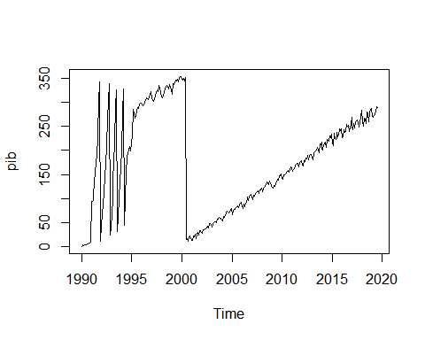

plot.ts(diff(pib))

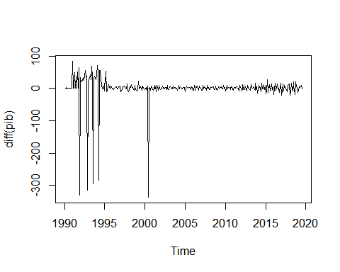

pib<-ts(dados[,2],start=1990,freq=12)

#2.2. Para fazer a análise da Função de Autocorrelação (FAC) e Autocorrelação parcial (FACp) com defasagem 36:  
acf(pib, lag.max=36)

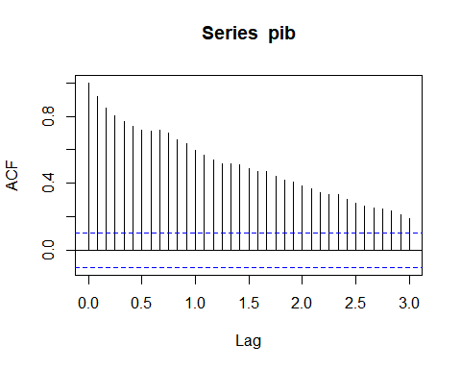

pacf(pib, lag.max=36)

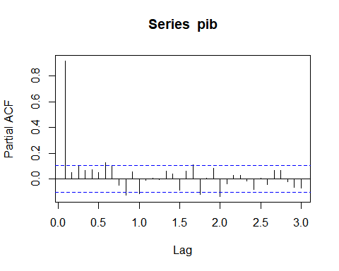

acf(diff(pib), lag.max=36)

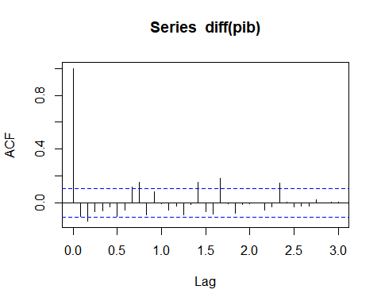

pacf(diff(pib), lag.max=36)

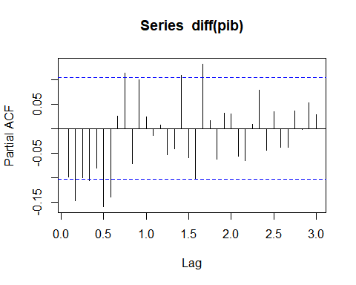

#Agora usando o comando decompose(), se decompõe a série em seus componentes tendência, aleatório, e sazonal.  
  
x<- decompose(pib)  
plot(x)

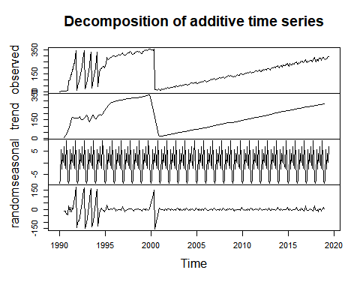

#2.4. Estimando o modelo ARIMA com comando:  
 #Comando geral: arima(data,order=c(p,d,q))  
arima(pib,order=c(2,1,1))

##   
## Call:  
## arima(x = pib, order = c(2, 1, 1))  
##   
## Coefficients:  
## ar1 ar2 ma1  
## 0.6104 -0.0907 -0.7705  
## s.e. 0.0877 0.0588 0.0726  
##   
## sigma^2 estimated as 1500: log likelihood = -1796.89, aic = 3601.78

x.fit <- arima(pib,order=c(2,1,1))

#2.5. Estimando o modelo ARIMA sazonal  
arima(pib,order=c(2,1,1),seasonal=list(order=c(2,1,1),period=12))

##   
## Call:  
## arima(x = pib, order = c(2, 1, 1), seasonal = list(order = c(2, 1, 1), period = 12))  
##   
## Coefficients:

## Warning in sqrt(diag(x$var.coef)): NaNs produzidos

## ar1 ar2 ma1 sar1 sar2 sma1  
## 0.5780 -0.0206 -0.7126 -0.5428 -0.339 -0.4048  
## s.e. 0.0016 NaN NaN 0.0012 NaN NaN  
##   
## sigma^2 estimated as 1849: log likelihood = -1776.82, aic = 3567.65

y.fit<-arima(pib,order=c(2,1,1),seasonal=list(order=c(2,1,1),period=12))  
y.fit

##   
## Call:  
## arima(x = pib, order = c(2, 1, 1), seasonal = list(order = c(2, 1, 1), period = 12))  
##   
## Coefficients:

## Warning in sqrt(diag(x$var.coef)): NaNs produzidos

## ar1 ar2 ma1 sar1 sar2 sma1  
## 0.5780 -0.0206 -0.7126 -0.5428 -0.339 -0.4048  
## s.e. 0.0016 NaN NaN 0.0012 NaN NaN  
##   
## sigma^2 estimated as 1849: log likelihood = -1776.82, aic = 3567.65

#2.6. Checagem e diagnóstico  
 #Com o comando tsdiag é possível analisar os gráficos dos resíduos ( O modelo deve apresentar os resíduos estacionários, com média zero e variância constante)  
 #lembre-se que o modelo ARIMA(2,1,1) foi chamado de x  
z<-arima(pib,order=c(2,1,1),seasonal=list(order=c(2,1,1),period=12))  
tsdiag(z)

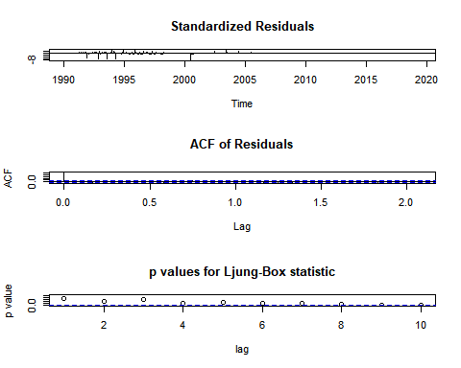

#Análise da estatística de Box–Pierce (e Ljung–Box)   
Box.test(z$residuals,lag=1)

##   
## Box-Pierce test  
##   
## data: z$residuals  
## X-squared = 0.10829, df = 1, p-value = 0.7421

#2.7. Previsão usando o modelo ( Forecasting)  
 #Use o comando predict()  
 #O termo n.ahead= 4, mostra quatro passos a frente e lembre-se que x é o nosso modelo ARIMA(2,1,1). Se você digitar forecast no R e der enter, irá aparecer os 4 dados previstos.   
  
require(forecast)

## Loading required package: forecast

## Warning: package 'forecast' was built under R version 3.6.1

## Registered S3 method overwritten by 'xts':  
## method from  
## as.zoo.xts zoo

## Registered S3 method overwritten by 'quantmod':  
## method from  
## as.zoo.data.frame zoo

## Registered S3 methods overwritten by 'forecast':  
## method from   
## fitted.fracdiff fracdiff  
## residuals.fracdiff fracdiff

forecast<-predict(z,n.ahead=10)

#2.8. Gráfico dos resultados  
 #Para fazer um gráfico com os valores mínimos e máximos das escalas das coordenadas e das abscissas, primeiramente deve-se encontrar esses valores com o comando summary.  
summary (pib)

## Min. 1st Qu. Median Mean 3rd Qu. Max.   
## 1.0 87.5 176.0 176.0 264.5 353.0

#Lembre-se para fazer o gráfico deve-se aumentar o valor máximo e também o tempo deve ser alterado, já considerando a previsão dos passos a frente.  
 # Como o dados do pib começam em 1990 e acabam em 2019, então como vamos prever 4 anos fica de 1990-2023.  
  
plot(pib,xlim=c(1994,2020),ylim=c(0, 500))

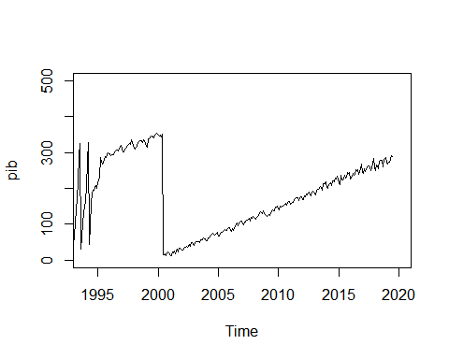

#previsão de 4 meses  
previsao <- predict(x.fit,n.ahead=4)  
plot(previsao$pred)

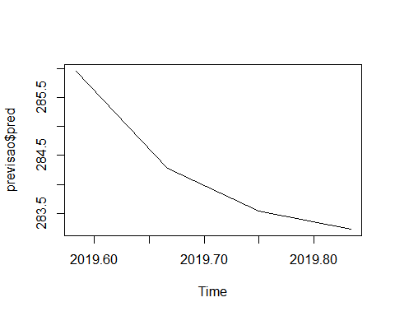

#2.9. Gráfico usando o comando:  
require(forecast)  
previsao <- forecast (x.fit)  
plot(forecast(x.fit))

